How do websites work?

What does HTML, CSS, and JavaScript do exactly?

Browser: like Chrome, Firefox, Safari there are all pieces of software that allow you to look up the IP address of your website and be able to receive data that it can render into the websites that we see.

The data you receive from the server usually consists of three types of files: HTML, CSS, and JavaScript.

HTML code file is responsible for the structure of your website. If a website was a house, the HTML would be the builder who would come in to build the walls, put in a toilet. You could use HTML to add an image, or button, text box, or text field whatever you need in your website.

CSS files are responsible for styling your website. If were building a house, then this would be the painters and decorators, painting the walls or adding stylistic flourishes to the house. Generally making the place look the way that you want it to. CSS allows you to specify how you want your website to look. Per se, I have a button I got from HTML, I want the button to be red, I want the text to be white, I want the font of the text to be Arial.

JavaScript code allows your website to actually do things or have behavior. If you were building a house, you would have the electrician come in who would be able to connect the wires so that your light bulbs actually lit up, or plumbing allows flush the toilet.

For example, Google website, once we receive these files from Google server, when our browser loads up the HTML files, we will see the structure of the website (Google name, textbox, search button, feeling lucky button, etc.),

CSS file will modify the appearance of all those components.

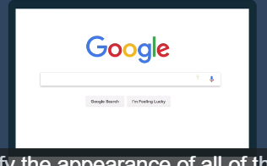

JavaScript file will start having behavior, functionality like typing, click search, etc.

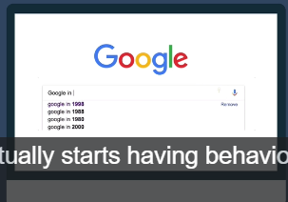

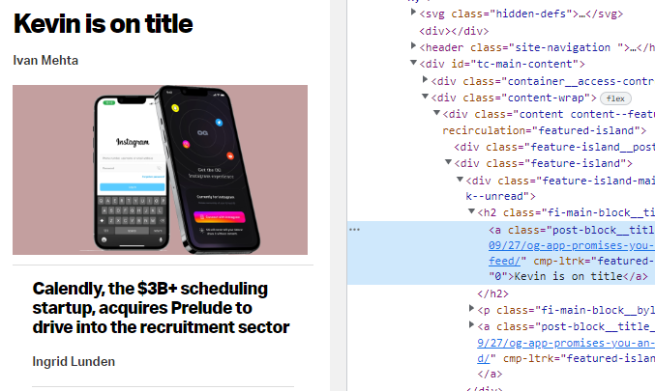

Do inspect, click and change something like the title, actually it changes the local copy of this file I got back from the server, but when I click refresh, that makes a new request to the servers to load up a fresh copy of the website, of course it updates to the original content.

Browser: they all have a single purpose, to interpret your files such as HTML files, CSS files, JavaScript files into a website that should be displayed. You can’t create a website using just CSS or just JavaScript. But you can create a website just with HTML, it does look very old fashion and boring seems from 90s.

HTML: hypertext markup language. Markup is very important.